Learning Factory: Iot table motor demo

|  |  |
| --- | --- |
| Last Edited by: | Last Edit: |
| Anoop Gadhrri | 18 October, 2017 |

# Document Brief

This document covers how to setup the Iot table, configure it with Mqtt, Kepserver and Node-red, Arduino-Ide

## Keywords

Mqtt, Node-red, Kepserver, PuTTy

# Process

;

Download windows 7 on a portable machine

Download KepServer, Node-red, Python, Hive-MQ

Reboot machine

Open disk imager and choose the little folder icon beside the search bar and find the Raspbian .iso file you downloaded

Choose the SD card you just inserted from the device section then click write button on the bottom

Run command prompt and type “node-red” to start our node-red server

Open your web browser and go to <http://localhosts:1880> and also <http://localhost:1880/ui> to display UI

Open KepServer, go to file and open our configured file pre-set for our plc

Go into settings and then import clipboard, choose our node-red config json file

Go to Hive-MQ folder and run the batch file that will initiate our MQTT broker

Open the Arduino Ide and upload our Arduino code onto it

Make sure all hardware is connected as directed by the set-up guide

Reboot our PLC so it may connect to the network and click deploy on our browser node-red IDE

*Notes: All config files and source codes are included on the supplied machine. If lost a backup will be available on the google drive for learning factory. The files locations are:*

* *Google Drive*
* *C:\Users\administrator\documents*

|  |  |  |  |  |  |  |
| --- | --- | --- | --- | --- | --- | --- |
| Operation |  | Description | Required Tools | Location | Reference Images | Notes |
| Step 1 |  | Download KepServer |  | <https://my.kepware.com/download/demo/ex/> | See Appx.1 |  |
| Step 2 |  | Import KepServer config file |  |  | See Appx.2 |  |
| Step 3 |  | Insatll node.js and npm |  | <https://www.npmjs.com/get-npm> |  | Follow online instructions from downloads page |
| Step 4 |  | Download node-red for windows |  |  | See Appx 3 for steps required | For instructions see: <https://www.youtube.com/watch?v=hEpeobDyj8k> |
| Step 5 |  | Open supplied text file and copy contents to the clip board |  |  |  |  |
| Step 6 |  | Import settings to node-red using the clipboard feature |  |  | See Appx.3 |  |
| Step 7 |  | Download Hive-MQ |  | https://www.hivemq.com/downloads/ | See Appx.4 |  |
| Step 8 |  | Run Hive-MQ by running batch file in downloaded folder |  |  |  |  |
| Step 9 |  | Download Arduino IDE |  | https://www.arduino.cc/en/Main/Software | See Appx.5 |  |
| step 10 |  | Upload our source code to Arduino and reboot machine |  |  |  |  |
| Step 11 |  | Set-up is now complete |  |  |  |  |

# Appendix

## Appx.1:

## C:\Users\Anoop\AppData\Local\Microsoft\Windows\INetCache\Content.Word\Capture.png

## Appx.2:

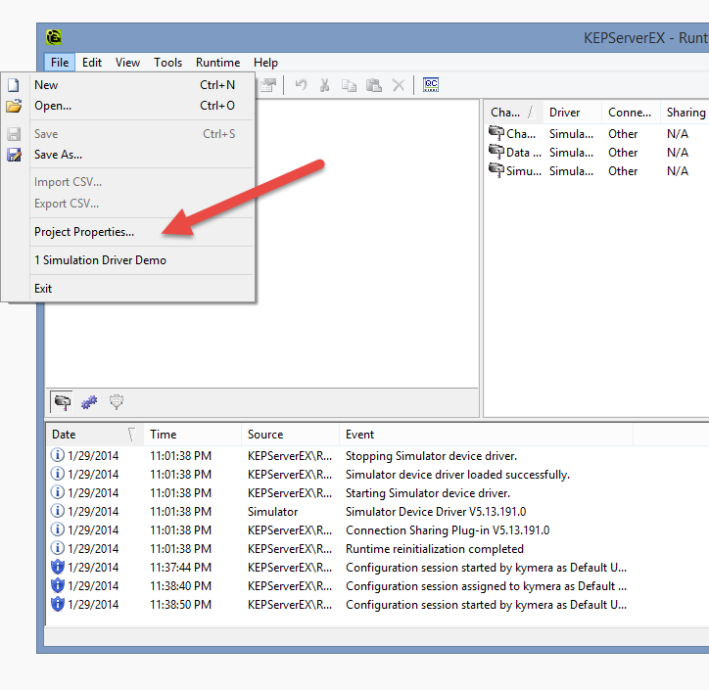

## Appx.3

Install steps:

1. Open a command prompt and type these commands
2. npm install -g --unsafe-perm node-red
3. npm install node-red-dashboard
4. node-red.

## Appx. 4

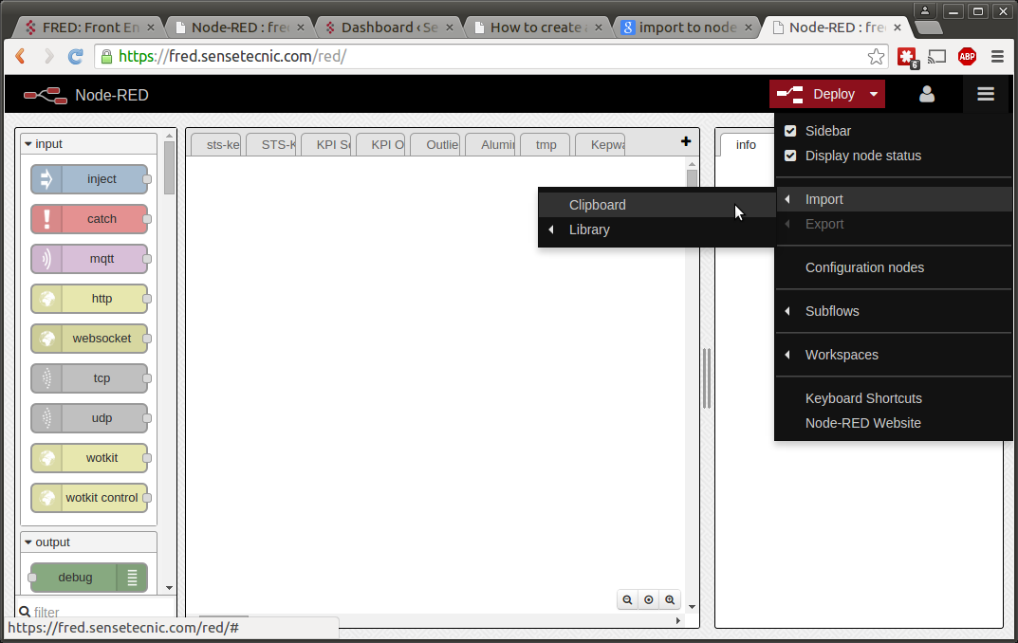

## Appx.5

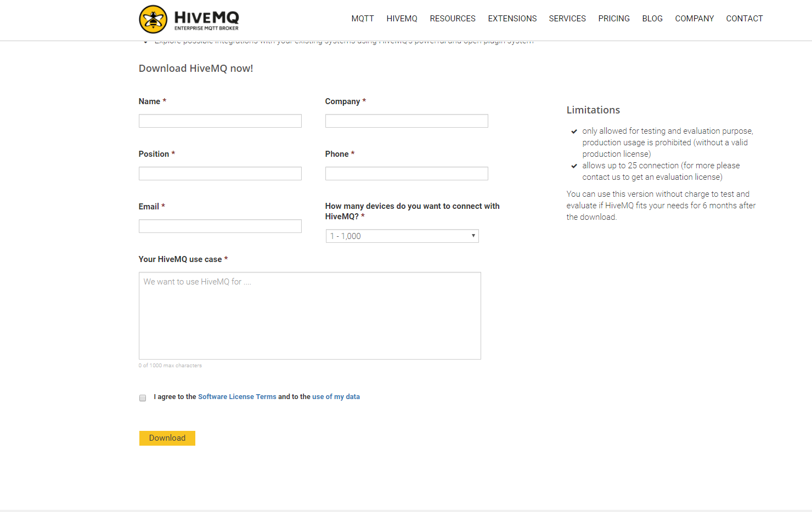

## Appx.6

